Exercise 1:

Start with the following list of numbers:

const numbers = [1, 2, 4, 7];

Print the square of each number: 1, 4, 16 and 49.

1. First, use a for loop.

2. Solve the problem again using a for-in loop.

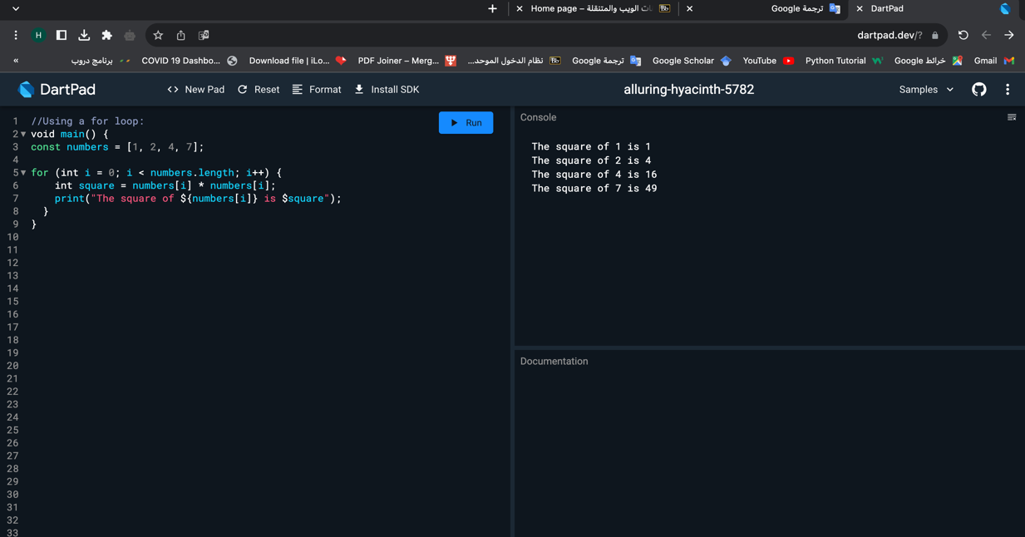

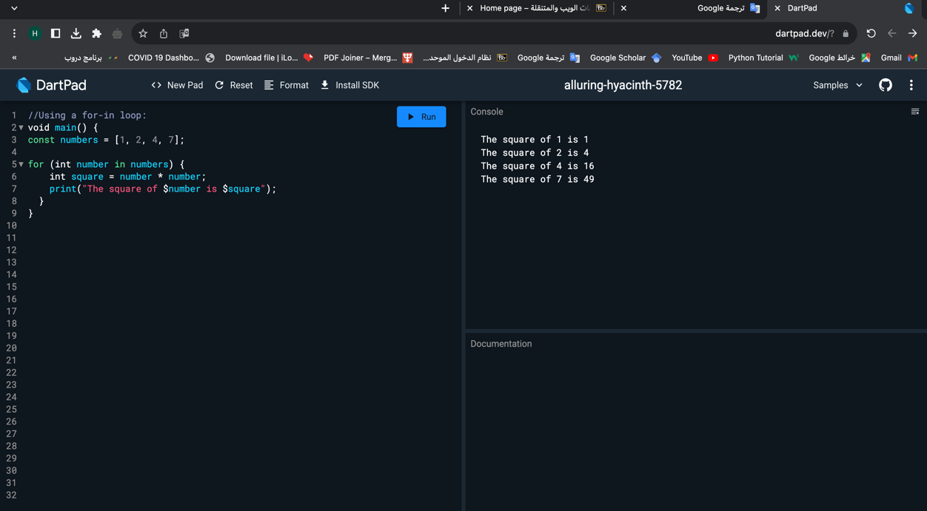

Exercise 2:

1. Create a class named User as follows:

class User {

int id = 213;

String name = 'Fatima';

}

1. Create an object using this class
2. Print the object you created.
3. What will appear in the screen.
4. Define a toString method.
5. Print the object again
6. What will appear in the screen.

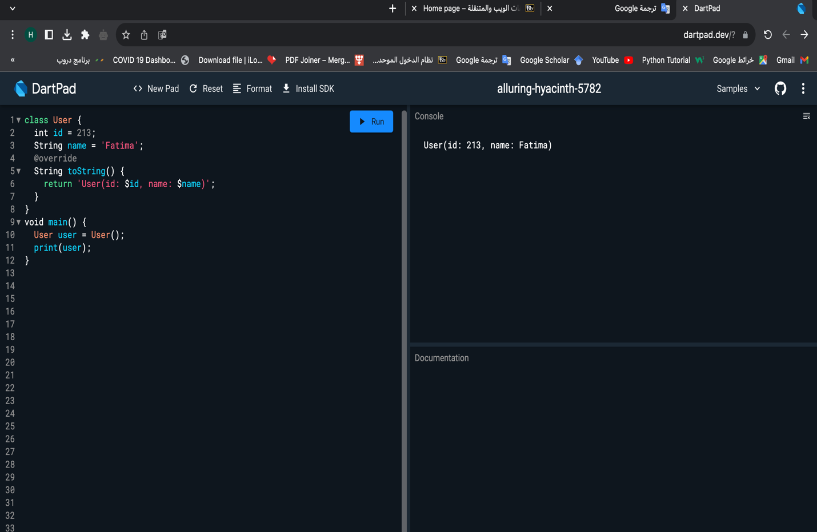

Exercise 3:

1. Create a constructor using the long-form, Short-Form, name constructor, and forwarding methods to initialize the id and the name of the user
2. Use the constructors to create an object from the class
3. Define a toString method.
4. Print the object again for each constructor you used

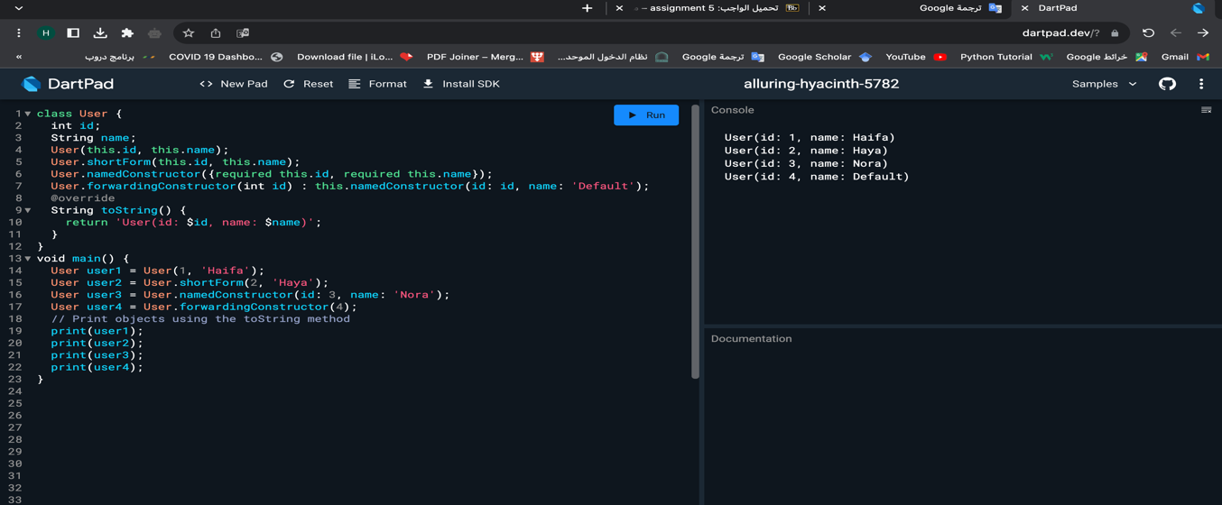

Exercise 4:

1. Define one of the previous constructor with name parameters.
2. Create object and print it.

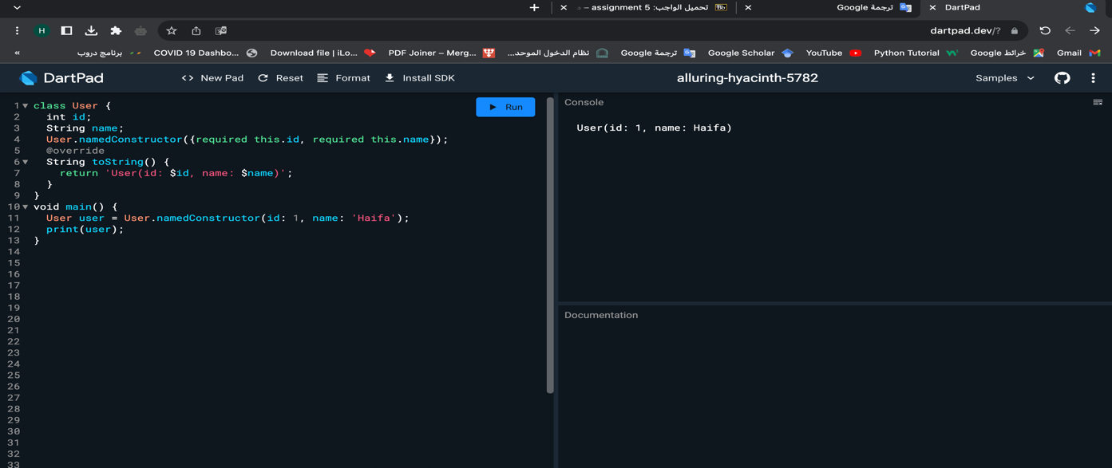

Exercise 5:

1. Define the previous class with private instance variables
2. Use set and get methods

